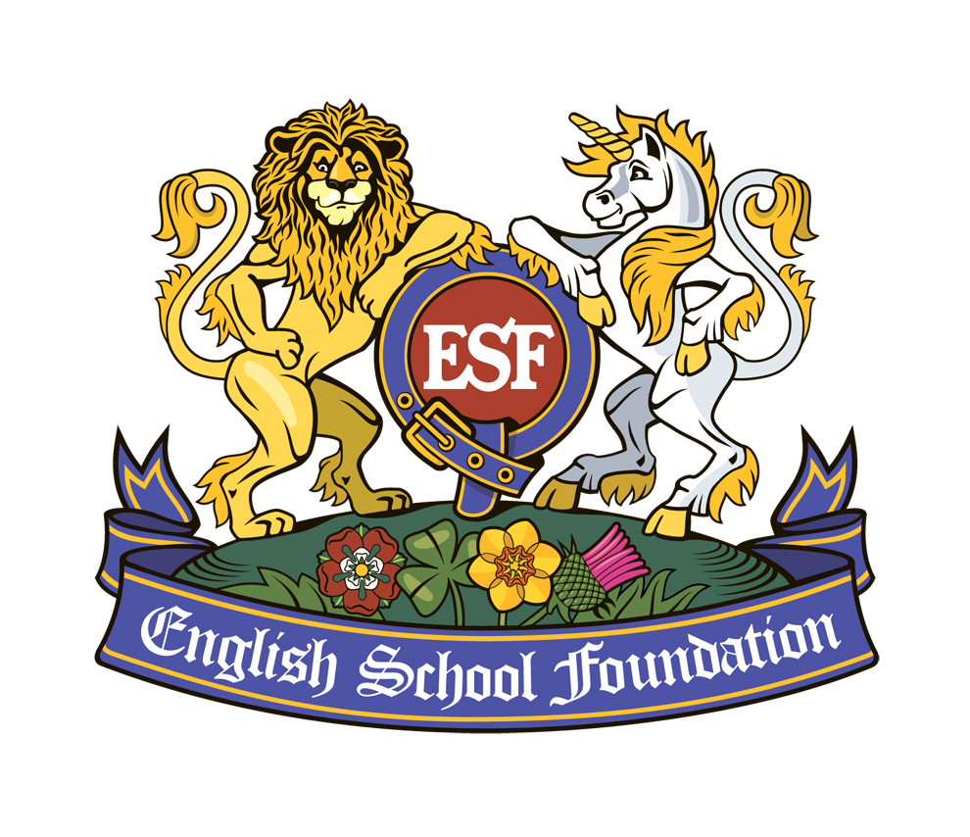 | ESS - The English School of Science & IT  Lefortovo Campus  www.english-school.org.uk 7-963-976-2228  12 Uhtomskaja Ul., 111020 Moscow
Ms. Victoria Proseraj, School Manager, victoria@english-school.org.uk
Ross Hunter, MA (Cambridge), Development Director rossdhunter@hotmail.com

9 June 2017
Dear Parents, Pupils & Friends,
School Progress Update, no.3

Greetings from ESS! This is the third in our series of letters to keep you up to date with ESS’ developments. If you are reading this in Moscow, I apologise for bringing English weather with me late last month; but the proper summer has arrived. The school is running, and functioning for our pioneer pupils in both primary and secondary. We have had exams, and are busy with end of year reports. There has been time for some educational trips out of school, to the Museum of the C20th on Tverskaya and to Kuskovo Park, with the beautiful Sheremetyevo mansion.

We continue to plan for September. Pupil numbers are growing, and we will absolutely have all primary classes, and secondary up to Y10. We are ready for the start of the “IGCSE” courses. This is the UK standard exam for 16 year olds, the proof of general education, normally taken in 6-9 subjects: English, Russian, Maths, 3xSciences, and humanities (history, geography) and creative subjects (art, music). We have the books for these, and a growing library for readers of all ages.

Although ESS moved to a new bigger campus and seems like a new school, we already have 9 years’ experience as we are an extension of the well-established ‘Children of the World’ primary school, and we share all our systems and licences. Note that ESS has chosen a brand new name (1.) to stress the curriculum and (2.) to avoid paying of the royalties to anyone else. ESS is a not-for-profit organization and unlike many international schools in Russia, nobody can benefit the school but our students and their families. This helps us keep our prices attractive.

A key focus of the school is, along with excellent English, a priority for Maths, Technology and Science (STEM). Not only is the teaching time generous, but there is a determination for children do learn by doing – to have hands on experience and practical skills. These are vital for university, A level and IGCSE, so we start inculcating good habits early on.

A healthy mind in a healthy body: the brain works better if it has plenty of oxygen, and if the body is fit and well exercises. Chess players have to sit still for long periods, and to concentrate on the board. To do this, they spend as much time keeping fit as working on their strategies: good moves come from good movement.

More next week. I hope you are ready for the summer, and will fit and refreshed for September.

Best wishes
Yours sincerely
Ross Hunter, MA (Cambridge)
Founding Development Director.

